Chapter 5
Interest Rates
5-1. Your bank is offering you an account that will pay 20% interest in total for a two-year deposit. Determine the equivalent discount rate for a period length of:
a. Six months.
b. One year.
c. One month.
a. Since 6 months is 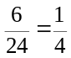 of 2 years, using our rule 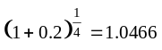.
So the equivalent 6 month rate is 4.66%.
b. Since one year is half of 2 years 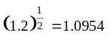
So the equivalent 1 year rate is 9.54%.
c. Since one month is 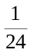 of 2 years, using our rule 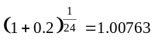
So the equivalent 1 month rate is 0.763%.
5-2. Which do you prefer: a bank account that pays 5% per year (EAR) for three years or:

a. An account that pays 2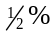 every six months for three years?
b. An account that pays 7 every 18 months for three years?
c. An account that pays per month for three years?
If you deposit $1 into a bank account that pays 5% per year for 3 years you will have 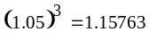 after 3 years.
a. If the account pays 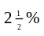 per 6 months then you will have 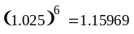 after 3 years, so you prefer every 6 months.
b. If the account pays 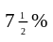 per 18 months then you will have 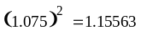 after 3 years, so you prefer 5% per year.
c. If the account pays 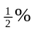 per month then you will have 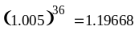 after 3 years, so you prefer every month.
5-3. Many academic institutions offer a sabbatical policy. Every seven years a professor is given a year free of teaching and other administrative responsibilities at full pay. For a professor earning $70,000 per year who works for a total of 42 years, what is the present value of the amount she will earn while on sabbatical if the interest rate is 6% (EAR)?
Timeline:
0 |  | 7 |  | 14 |  |  |  |  | 42
 |  | 70,000 |  | 70,000 |  |  |  |  | 70,000
Because 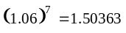, the equivalent discount rate for a 7-year period is 50.363%.
Using the annuity formula:
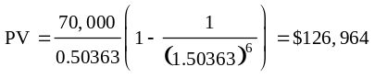
5-4. You have found three investment choices for a one-year deposit: 10% APR compounded monthly, 10% APR compounded annually, and 9% APR compounded daily. Compute the EAR for each investment choice. (Assume that there are 365 days in the year.)
For a $1 invested in an account with 10% APR with monthly compounding you will have:
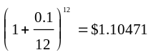
So the EAR is 10.471%.
For a $1 invested in an account with 10% APR with annual compounding you will have:
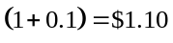
So the EAR is 10%.
For a $1 invested in an account with 9% APR with daily compounding you will have:
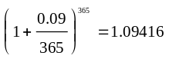
So the EAR is 9.416%.
5-5. You are considering moving your money to new bank offering a one-year CD that pays an 8% APR with monthly compounding. Your current bank’s manager offers to match the rate you have been offered. The account at your current bank would pay interest every six months. How much interest will you need to earn every six months to match the CD?
With 8% APR, we can calculate the EAR as follows:
EAR = 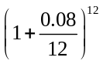= 8.3%
Over six months this works out to be 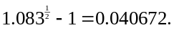 Hence you need to earn 4.0672% interest rate to match the CD.
5-6. Your bank account pays interest with an EAR of 5%. What is the APR quote for this account based on semiannual compounding? What is the APR with monthly compounding?
Using the formula for converting from an EAR to an APR quote:
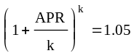
Solving for the APR:
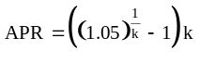
With annual payments k = 1, so APR = 5%
With semiannual payments k = 2, so APR = 4.939%
With monthly payments k = 12, so APR = 4.889%
5-7. Suppose the interest rate is 8% APR with monthly compounding. What is the present value of an annuity that pays $100 every six months for five years?
Using the PV of an annuity formula with N = 10 payments and C = $100 with r = 4.067% per 6 month interval, since there is an 8% APR with monthly compounding: 8% / 12 = 0.6667% per month, or (1.006667)^6 – 1 = 4.067% per 6 months.
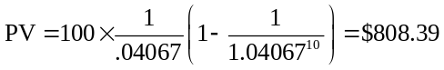
5-8. You can earn $50 in interest on a $1000 deposit for eight months. If the EAR is the same regardless of the length of the investment, determine how much interest you will earn on a $1000 deposit for:
a. 6 months.
b. 1 year.
c. 1 years.
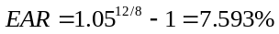
a) 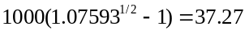
b) 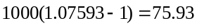
c) 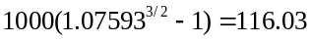
5-9. Suppose you invest $100 in a bank account, and five years later it has grown to $134.39.
a. What APR did you receive, if the interest was compounded semiannually?
b. What APR did you receive if the interest was compounded monthly?
The EAR can be calculated as follows:
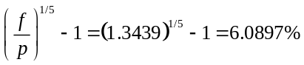
a) Using the formula for EAR, we can calculate the APR for semiannual compounding.
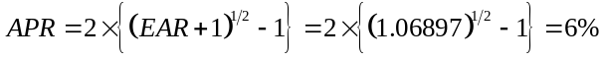
b) Similarly we can calculate the APR for monthly compounding:
5-10. Your son has been accepted into college. This college guarantees that your son’s tuition will not increase for the four years he attends college. The first $10,000 tuition payment is due in six months. After that, the same payment is due every six months until you have made a total of eight payments. The college offers a bank account that allows you to withdraw money every six months and has a fixed APR of 4% (semiannual) guaranteed to remain the same over the next four years. How much money must you deposit today if you intend to make no further deposits and would like to make all the tuition payments from this account, leaving the account empty when the last payment is made?
Timeline:
0 |  |  |  | 1 |  |  |  |  | 4
0 |  | 1 |  | 2 |  |  |  |  | 8
 |  | 10,000 |  | 10,000 |  |  |  |  | 10,000
4% APR (semiannual) implies a semiannual discount rate of 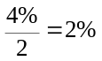
So, 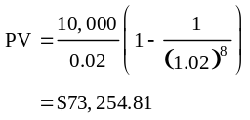
5-11. You make monthly payments on your mortgage. It has a quoted APR of 5% (monthly compounding). What percentage of the outstanding principal do you pay in interest each month?
Using the formula for computing the discount rate from an APR quote:
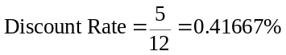
5-12. Capital One is advertising a 60-month, 5.99% APR motorcycle loan. If you need to borrow $8000 to purchase your dream Harley Davidson, what will your monthly payment be?
Timeline:
0 |  | 1 |  | 2 |  | 3 |  | 4 |  |  |  |  | 60
–8,000 |  | C |  | C |  | C |  | C |  |  |  |  | C
5.99 APR monthly implies a discount rate of:
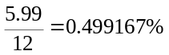
Using the formula for computing a loan payment
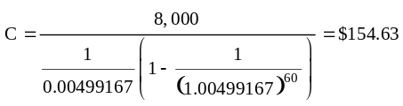
5-13. Oppenheimer Bank is offering a 30-year mortgage with an EAR of 5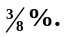 If you plan to borrow $150,000, what will your monthly payment be?
Timeline:
0 |  | 1 |  | 2 |  | 3 |  | 4 |  |  |  |  | 360
–150,000 |  | C |  | C |  | C |  | C |  |  |  |  | C
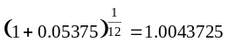
So 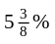 EAR implies a discount rate of 0.43725%
Using the formula for computing a loan payment
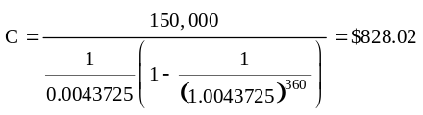
5-14. You have decided to refinance your mortgage. You plan to borrow whatever is outstanding on your current mortgage. The current monthly payment is $2356 and you have made every payment on time. The original term of the mortgage was 30 years, and the mortgage is exactly four years and eight months old. You have just made your monthly payment. The mortgage interest rate is 63⁄8% (APR). How much do you owe on the mortgage today?
Timeline:
56 |  | 57 |  | 58 |  |  |  |  | 360
0 |  | 1 |  | 2 |  |  |  |  | 304
 |  | 2,356 |  | 2,356 |  |  |  |  | 2,356
To find out what is owed, compute the PV of the remaining payments using the loan interest rate to compute the discount rate:
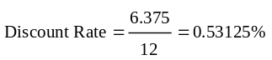
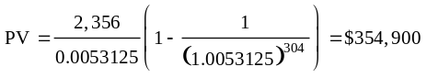
5-15. You have just sold your house for $1,000,000 in cash. Your mortgage was originally a 30-year mortgage with monthly payments and an initial balance of $800,000. The mortgage is currently exactly 181⁄2 years old, and you have just made a payment. If the interest rate on the mortgage is 5.25% (APR), how much cash will you have from the sale once you pay off the mortgage?
First we need to compute the original loan payment
Timeline #1:
0 |  | 1 |  | 2 |  | 3 |  |  |  |  | 360
–800,000 |  | C |  | C |  | C |  |  |  |  | C
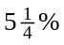 APR (monthly) implies a discount rate of 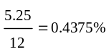
Using the formula for a loan payment
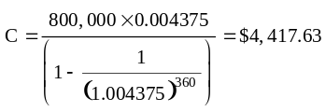
Now we can compute the PV of continuing to make these payments
The timeline is
Timeline #2:
222 |  | 223 |  | 224 |  | 225 |  |  |  |  | 360
0 |  | 1 |  | 2 |  | 3 |  |  |  |  | 138
 |  | 4,417.63 |  | 4,417.63 |  | 4,417.63 |  |  |  |  | 4,417.63
Using the formula for the PV of an annuity
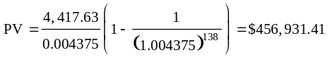
So, you would keep $1,000,000 - $456,931 = $543,069.
5-16. You have just purchased a home and taken out a $500,000 mortgage. The mortgage has a 30-year term with monthly payments and an APR of 6%.
a. How much will you pay in interest, and how much will you pay in principal, during the first year?
b. How much will you pay in interest, and how much will you pay in principal, during the 20th year (i.e., between 19 and 20 years from now)?
a. APR of 6% = 0.5% per month. Payment = 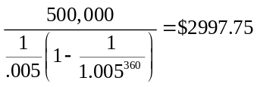.
Total annual payments = 2997.75 × 12 = $35,973.
Loan balance at the end of 1 year =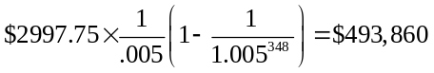.
Therefore, 500,000 – 493,860 = $6140 in principal repaid in first year, and 35,973 – 6140 = $29,833 in interest paid in first year.
b. Loan balance in 19 years (or 360 – 19×12 = 132 remaining pmts) is
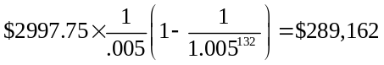.
Loan balance in 20 years = 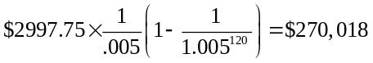.
Therefore, 289,162 – 270,018 = $19,144 in principal repaid, and $35,973 – 19,144 = $16,829 in interest repaid.
5-17. Your mortgage has 25 years left, and has an APR of 7.625% with monthly payments of $1449.
a. What is the outstanding balance?
b. Suppose you cannot make the mortgage payment and you are in danger of losing your house to foreclosure. The bank has offered to renegotiate your loan. The bank expects to get $150,000 for the house if it forecloses. They will lower your payment as long as they will receive at least this amount (in present value terms). If current 25-year mortgage interest rates have dropped to 5% (APR), what is the lowest monthly payment you could make for the remaining life of your loan that would be attractive to the bank?
a. The monthly discount rate is
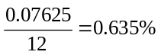
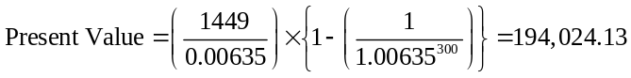
b. Here the present value is $150,000 and the monthly payment needs to be calculated.
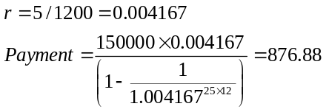
5-18. You have an outstanding student loan with required payments of $500 per month for the next four years. The interest rate on the loan is 9% APR (monthly). You are considering making an extra payment of $100 today (that is, you will pay an extra $100 that you are not required to pay). If you are required to continue to make payments of $500 per month until the loan is paid off, what is the amount of your final payment? What effective rate of return (expressed as an APR with monthly compounding) have you earned on the $100?
We begin with the timeline of our required payments
(1) Let’s compute our remaining balance on the student loan. As we pointed out earlier, the remaining balance equals the present value of the remaining payments. The loan interest rate is 9% APR, or 9% / 12 = 0.75% per month, so the present value of the payments is
47
–500
0
2
–500
1
–500
48
–500
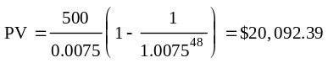
Using the annuity spreadsheet to compute the present value, we get the same number:

N | I | PV | PMT | FV
48 | 0.75 % | 20,092.39 | –500 | 0

Thus, your remaining balance is $20,092.39.
If you prepay an extra $100 today, your will lower your remaining balance to $20,092.39 – 100 = $19,992.39. Though your balance is reduced, your required monthly payment does not change. Instead, you will pay off the loan faster; that is, it will reduce the payments you need to make at the very end of the loan. How much smaller will the final payment be? With the extra payment, the timeline changes:
47
–500
0
19,992.39
2
–500
1
–500
48
–(500 – X)
That is, we will pay off the loan by paying $500 per month for 47 months, and some smaller amount, $500 – X, in the last month. To solve for X, recall that the PV of the remaining cash flows equals the outstanding balance when the loan interest rate is used as the discount rate:
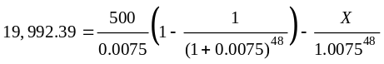
Solving for X gives
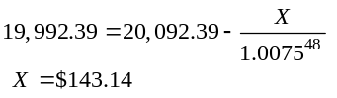
So the final payment will be lower by $143.14.
You can also use the annuity spreadsheet to determine this solution. If you prepay $100 today, and make payments of $500 for 48 months, then your final balance at the end will be a credit of $143.14:

N | I | PV | PMT | FV
48 | 0.75 % | 19,992.39 | –500 | 143.14

(2) The extra payment effectively lets us exchange $100 today for $143.14 in four years. We claimed that the return on this investment should be the loan interest rate. Let’s see if this is the case:
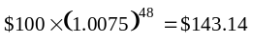, so it is.
Thus, you earn a 9% APR (the rate on the loan).
5-19. Consider again the setting of Problem 18. Now that you realize your best investment is to prepay your student loan, you decide to prepay as much as you can each month. Looking at your budget, you can afford to pay an extra $250 per month in addition to your required monthly payments of $500, or $750 in total each month. How long will it take you to pay off the loan?
The timeline in this case is:
and we want to determine the number of monthly payments N that we will need to make. That is, we need to determine what length annuity with a monthly payment of $750 has the same present value as the loan balance, using the loan interest rate as the discount rate. As we did in Chapter 4, we set the outstanding balance equal to the present value of the loan payments and solve for N.
N
-750
0
20,092.39
2
-750
1
-750
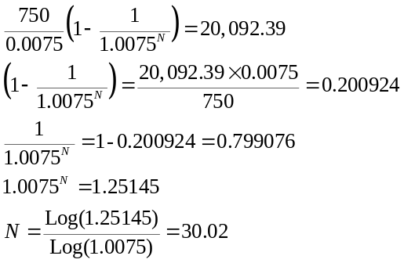
We can also use the annuity spreadsheet to solve for N.

N | I | PV | PMT | FV
30.02 | 0.75 % | 20,092.39 | –750 | 0

So, by prepaying the loan, we will pay off the loan in about 30 months or 2 ½ years, rather than the four years originally scheduled. Because N of 30.02 is larger than 30, we could either increase the 30th payment by a small amount or make a very small 31st payment. We can use the annuity spreadsheet to determine the remaining balance after 30 payments.

N | I | PV | PMT | FV
30 | 0.75 % | 20,092.39 | –750 | –13.86

If we make a final payment of $750.00 + $13.86 = $763.86, the loan will be paid off in 30 months.
5-20. Oppenheimer Bank is offering a 30-year mortgage with an APR of 5.25% based on monthly compounding. With this mortgage your monthly payments would be $2000 per month. In addition, Oppenheimer Bank offers you the following deal: Instead of making the monthly payment of $2000 every month, you can make half the payment every two weeks (so that you will make 52 ⁄ 2 = 26 payments per year). With this plan, how long will it take to pay off the mortgage if the EAR of the loan is unchanged?
For the original mortgage, we are paying $2000 per month, at a monthly interest rate of 5.25%/12 = 0.4375% per month, for 360 months. Therefore the original loan amount is equal to the present value:

PV(original loan pmts) = 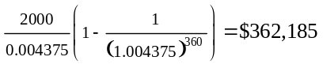

The new loan will have payments of $1000 every 2 weeks or 26 times per year. First we must solve for the equivalent two week interest rate r which has the same EAR as the original loan:
To compute the number of payments N, we set the PV of the loan payments equal to the original balance
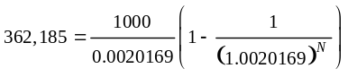
and solve for N using an annuity calculator, Excel NPER function, trial and error, or directly as follows:
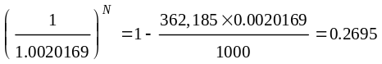
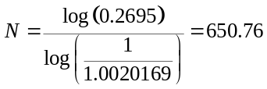
So it will take 651 payments to pay off the mortgage (the last payment will be a bit less than $1000). Since there are 26 payments per year, this will take 651/26 = 25 years + 2 weeks. We shorten the payment time by nearly 5 years because there are approximately 2 extra payments every year (26 x $1000 = $26,000 total payments per year versus 12 x $2000 = $24,000 per year).
5-21. Your friend tells you he has a very simple trick for shortening the time it takes to repay your mortgage by one-third: Use your holiday bonus to make an extra payment on January 1 of each year (that is, pay your monthly payment due on that day twice). If you take out your mortgage on July 1, so your first monthly payment is due August 1, and you make an extra payment every January 1, how long will it take to pay off the mortgage? Assume that the mortgage has an original term of 30 years and an APR of 12% based on monthly compounding.
The principle balance does not matter, so just pick 100,000. Begin by computing the monthly payment. Given the loan APR, the discount rate is 12%/12 = 1%.
Timeline #1:
0 |  | 1 |  | 2 |  |  |  |  | 360
100,000 |  | –C |  | –C |  |  |  |  | –C
Using the formula for the loan payment,
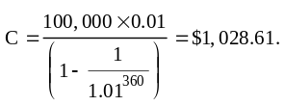
Let’s consider the payments you will make over the first year, including the extra January payment. The timeline is:

0 |  | 1=Aug |  |  | 6=Jan |  | 7=Feb |  |  |  | 12=July
 |  | –1028.61 |  |  | –1028.61 |  | –1028.61 |  |  |  | –1028.61
 |  |  |  |  | -1028.61
Let’s find the equivalent one time annual payment to these cash flows (as though we only made a single payment each July). The future value of the above cash flows is the future value of the monthly annuity plus the future value of the extra January payment:
So, the new payment plan is equivalent to paying $14,137 at the end of every year. At that rate, how long will it take to pay off the loan? We need to find the number of years N for an annual annuity of $14,137, such that given an EAR of 1.01¹²-1 = 12.683%, the PV = $100,000:

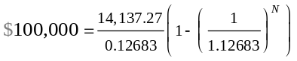
We can solve for N using an annuity calculator, with Excel (NPER function), by trial and error, or directly as follows:
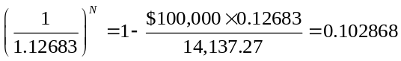
Therefore,
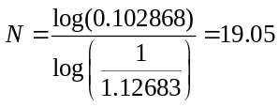
Thus, it will take just over 19 years to payoff the mortgage, and your friend is right!
5-22. You need a new car and the dealer has offered you a price of $20,000, with the following payment options: (a) pay cash and receive a $2000 rebate, or (b) pay a $5000 down payment and finance the rest with a 0% APR loan over 30 months. But having just quit your job and started an MBA program, you are in debt and you expect to be in debt for at least the next 2 years. You plan to use credit cards to pay your expenses; luckily you have one with a low (fixed) rate of 15% APR (monthly). Which payment option is best for you?
You can use any money that you don’t spend on the car to pay down your credit card debt. Paying down the loan is equivalent to an investment earning the loan rate of 15% APR. Thus, your opportunity cost of capital is 15% APR (monthly) and so the discount rate is 15/12 = 1.25% per month. Computing the present value of option (ii) at this discount rate, we find
PV(ii)
You are better off taking the loan from the dealer and using any extra money to pay down your credit card debt.
5-23. The mortgage on your house is five years old. It required monthly payments of $1402, had an original term of 30 years, and had an interest rate of 10% (APR). In the intervening five years, interest rates have fallen and so you have decided to refinance—that is, you will roll over the outstanding balance into a new mortgage. The new mortgage has a 30-year term, requires monthly payments, and has an interest rate of 6 5⁄8% (APR).
a. What monthly repayments will be required with the new loan?
b. If you still want to pay off the mortgage in 25 years, what monthly payment should you make after you refinance?
c. Suppose you are willing to continue making monthly payments of $1402. How long will it take you to pay off the mortgage after refinancing?
d. Suppose you are willing to continue making monthly payments of $1402, and want to pay off the mortgage in 25 years. How much additional cash can you borrow today as part of the refinancing?
a. First, we calculate the outstanding balance of the mortgage. There are 25 × 12 = 300 months remaining on the loan, so the timeline is as follows.
Timeline #1:
0 |  | 1 |  | 2 |  |  |  |  | 300
 |  | 1,402 |  | 1,402 |  |  |  |  | 1,402
To determine the outstanding balance we discount at the original rate, i.e., 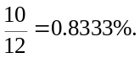
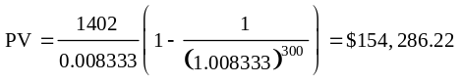
Next we calculate the loan payment on the new mortgage.
Timeline #2:
0 |  | 1 |  | 2 |  |  |  |  | 360
154,286.22 |  | –C |  | –C |  |  |  |  | –C
The discount rate on the new loan is the new loan rate: 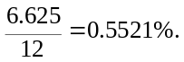
Using the formula for the loan payment:
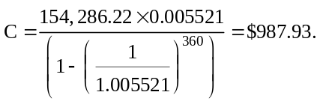
b. 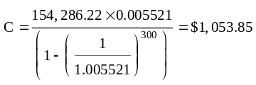
c. 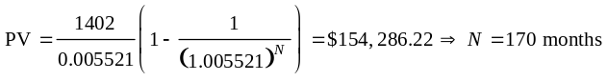 (You can use trial and error or the annuity calculator to solve for N.)
d. 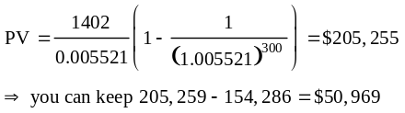
(Note: results may differ slightly due to rounding.)
5-24. You have credit card debt of $25,000 that has an APR (monthly compounding) of 15%. Each month you pay the minimum monthly payment only. You are required to pay only the outstanding interest. You have received an offer in the mail for an otherwise identical credit card with an APR of 12%. After considering all your alternatives, you decide to switch cards, roll over the outstanding balance on the old card into the new card, and borrow additional money as well. How much can you borrow today on the new card without changing the minimum monthly payment you will be required to pay?
The discount rate on the original card is:
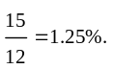
Assuming that your current monthly payment is the interest that accrues, it equals:
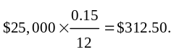
Timeline:
0 |  | 1 |  | 2
 |  | 312.50 |  | 312.50
This is a perpetuity. So the amount you can borrow at the new interest rate is this cash flow discounted at the new discount rate. The new discount rate is 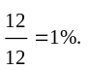
So,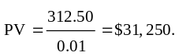
So by switching credit cards you are able to spend an extra 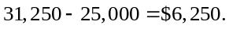
You do not have to pay taxes on this amount of new borrowing, so this is your after-tax benefit of switching cards.
5-25. In 1975, interest rates were 7.85% and the rate of inflation was 12.3% in the United States. What was the real interest rate in 1975? How would the purchasing power of your savings have changed over the year?
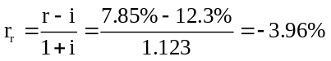
The purchasing power of your savings declined by 3.96% over the year.
5-26. If the rate of inflation is 5%, what nominal interest rate is necessary for you to earn a 3% real interest rate on your investment?
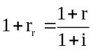 implies .
Therefore, a nominal rate of 8.15% is required.
5-27. Can the nominal interest rate available to an investor be significantly negative? (Hint: Consider the interest rate earned from saving cash “under the mattress.”) Can the real interest rate be negative? Explain.
By holding cash, an investor earns a nominal interest rate of 0%. Since an investor can always earn at least 0%, the nominal interest rate cannot be negative. The real interest rate can be negative, however. It is negative whenever the rate of inflation exceeds the nominal interest rate.
5-28. Consider a project that requires an initial investment of $100,000 and will produce a single cash flow of $150,000 in five years.
a. What is the NPV of this project if the five-year interest rate is 5% (EAR)?
b. What is the NPV of this project if the five-year interest rate is 10% (EAR)?
c. What is the highest five-year interest rate such that this project is still profitable?
a. NPV = –100,000 + 150,000 / 1.05⁵ = $17,529.
b. NPV = –100,000 + 150,000 / 1.10⁵ = –$6862.
c. The answer is the IRR of the investment: IRR = (150,000 / 100,000)1/5 – 1 = 8.45%.
5-29. Suppose the term structure of risk-free interest rates is as shown below:
a. Calculate the present value of an investment that pays $1000 in two years and $2000 in five years for certain.
b. Calculate the present value of receiving $500 per year, with certainty, at the end of the next five years. To find the rates for the missing years in the table, linearly interpolate between the years for which you do know the rates. (For example, the rate in year 4 would be the average of the rate in year 3 and year 5.)
c. Calculate the present value of receiving $2300 per year, with certainty, for the next 20 years. Infer rates for the missing years using linear interpolation. (Hint: Use a spreadsheet.)
a. Timeline:
0 |  | 1 |  | 2 |  | 3 |  | 4 |  | 5
 |  |  |  | 1,000 |  |  |  |  |  | 2,000
Since the opportunity cost of capital is different for investments of different maturities, we must use the cost of capital associated with each cash flow as the discount rate for that cash flow:
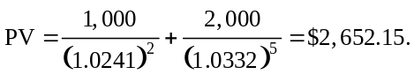
b. Timeline:
0 |  | 1 |  | 2 |  | 3 |  | 4 |  | 5
 |  | 500 |  | 500 |  | 500 |  | 500 |  | 500
Since the opportunity cost of capital is different for investments of different maturities, we must use the cost of capital associated with each cash flow as the discount rate for that cash flow. Unfortunately, we do not have a rate for a 4-year cash flow, so we linearly interpolate.
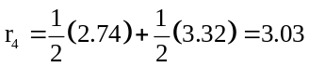
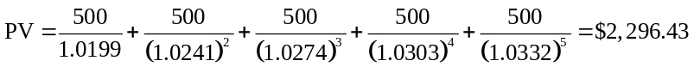
c. Timeline:
0 |  | 1 |  | 2 |  | 3 |  |  |  |  | 20
 |  | 2,300 |  | 2,300 |  | 2,300 |  |  |  |  | 2,300
Since the opportunity cot of capital is different for investments of different maturities, we must use the cost of capital associated with each cash flow as the discount rate for that cash flow. Unfortunately, we do not have a rate for a number of years, so we linearly interpolate.
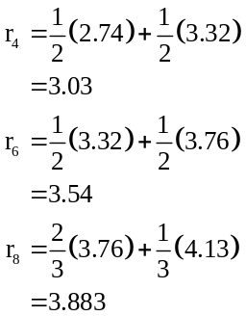
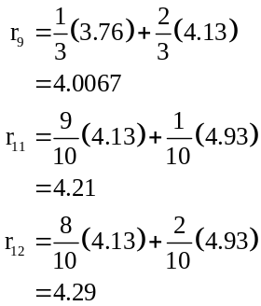
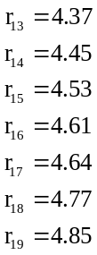
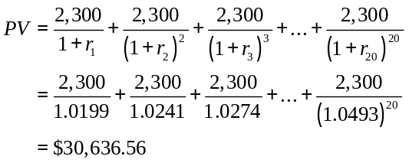
5-30. Using the term structure in Problem 29, what is the present value of an investment that pays $100 at the end of each of years 1, 2, and 3? If you wanted to value this investment correctly using the annuity formula, which discount rate should you use?
PV = 100 / 1.0199 + 100 / 1.0241² + 100 / 1.0274³ = $285.61.
To determine the single discount rate that would compute the value correctly, we solve the following for r:
PV = 285.61 = 100/(1 + r) + 100 / (1 + r)² + 100/(1 + r)³ = $285.61.
This is just an IRR calculation. Using trial and error or the annuity calculator, r = 2.50%. Note that this rate is between the 1, 2, and 3-yr rates given.
5-31. What is the shape of the yield curve given the term structure in Problem 29? What expectations are investors likely to have about future interest rates?
The yield curve is increasing. This is often a sign that investors expect interest rates to rise in the future.
5-32. Suppose the current one-year interest rate is 6%. One year from now, you believe the economy will start to slow and the one-year interest rate will fall to 5%. In two years, you expect the economy to be in the midst of a recession, causing the Federal Reserve to cut interest rates drastically and the one-year interest rate to fall to 2%. The one-year interest rate will then rise to 3% the following year, and continue to rise by 1% per year until it returns to 6%, where it will remain from then on.
a. If you were certain regarding these future interest rate changes, what two-year interest rate would be consistent with these expectations?
b. What current term structure of interest rates, for terms of 1 to 10 years, would be consistent with these expectations?
c. Plot the yield curve in this case. How does the one-year interest rate compare to the 10-year interest rate?
a. The one-year interest rate is 6%. If rates fall next year to 5%, then if you reinvest at this rate over two years you would earn (1.06)(1.05) = 1.113 per dollar invested. This amount corresponds to an EAR of (1.113)^{1/2} – 1 = 5.50% per year for two years. Thus, the two-year rate that is consistent with these expectations is 5.50%.
b. We can apply the same logic for future years:
c. 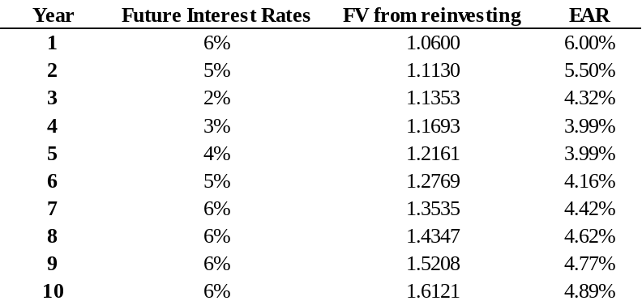We can plot the yield curve using the EARs in (b); note that the 10-year rate is below the 1-year rate (yield curve is inverted).
5-33. Figure 5.4 shows that CBS’s five-year borrowing rate is 1.3% and JPMorgan Chases’ is 2.6%. Which would you prefer? $500 from CBS paid today or a promise that the firm will pay you $550 in five years? Which would you choose if JPMorgan Chase offered you the same alternative?
The value today of CBS’s promise to pay $550 in 5 years is 550/(1.013)^5 = $515.60, so you would prefer to take $550 in 5 years. For JPMorgan Chase the promise is worth 550/(1.026)^5 = $483.76 so now you are better off taking the cash today.
5-34. Your best taxable investment opportunity has an EAR of 4%. You best tax-free investment opportunity has an EAR of 3%. If your tax rate is 30%, which opportunity provides the higher after-tax interest rate?
After-tax rate = 4%(1 – .30) = 2.8%, which is less than your tax-free investment with pays 3%.
5-35. Your uncle Fred just purchased a new boat. He brags to you about the low 7% interest rate (APR, monthly compounding) he obtained from the dealer. The rate is even lower than the rate he could have obtained on his home equity loan (8% APR, monthly compounding). If his tax rate is 25% and the interest on the home equity loan is tax deductible, which loan is truly cheaper?
After-tax cost of home equity loan is 8%(1 – .25) = 6%, which is cheaper than the dealer’s loan (for which interest is not tax-deductible). Thus, the home equity loan is cheaper. (Note that this could also be done in terms of EARs.)
5-36. You are enrolling in an MBA program. To pay your tuition, you can either take out a standard student loan (so the interest payments are not tax deductible) with an EAR of 5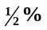 or you can use a tax-deductible home equity loan with an APR (monthly) of 6%. You anticipate being in a very low tax bracket, so your tax rate will be only 15%. Which loan should you use?
Using the formula to convert an APR to an EAR:
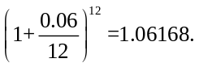
So the home equity loan has an EAR of 6.168%. Now since the rate on a tax deductible loan is a before-tax rate, we must convert this to an after-tax rate to compare it.
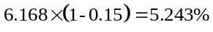
Since the student loan has a larger after tax rate, you are better off using the home equity loan.
5-37. Your best friend consults you for investment advice. You learn that his tax rate is 35%, and he has the following current investments and debts:
■ A car loan with an outstanding balance of $5000 and a 4.8% APR (monthly compounding)
■ Credit cards with an outstanding balance of $10,000 and a 14.9% APR (monthly compounding)
■ A regular savings account with a $30,000 balance, paying a 5.50% EAR
■ A money market savings account with a $100,000 balance, paying a 5.25% APR (daily compounding)
■ A tax-deductible home equity loan with an outstanding balance of $25,000 and a 5.0% APR (monthly compounding)
a. Which savings account pays a higher after-tax interest rate?
b. Should your friend use his savings to pay off any of his outstanding debts? Explain.
a. The regular savings account pays 5.5% EAR, or 5.5%(1 – .35) = 3.575% after tax. The money-market account pays (1 + 5.25%/365)³⁶⁵ – 1 = 5.39% or 5.39%(1 – .35) = 3.50% after tax. Therefore, the regular savings account pays a higher rate.
b. Your friend should pay off the credit card loans and the car loan, since they have after-tax costs of 14.9% APR and 4.8% APR respectively, which exceed the rate earned on savings. The home equity loan should not be repaid, as its EAR = (1 + 5%/12)¹² – 1 = 5.12%, for an after-tax rate of only 5.125(1 – .35) = 3.33%, which is below the rate earned on savings.
5-38. Suppose you have outstanding debt with an 8% interest rate that can be repaid anytime, and the interest rate on U.S. Treasuries is only 5%. You plan to repay your debt using any cash that you don’t invest elsewhere. Until your debt is repaid, what cost of capital should you use when evaluating a new risk-free investment opportunity? Why?
The appropriate cost of capital for a new risk-free investment is 8%, since you could earn 8% without risk by paying off your existing loan and avoiding interest charges.
5-39. In the summer of 2008, at Heathrow Airport in London, Bestofthebest (BB), a private company, offered a lottery to win a Ferrari or 90,000 British pounds, equivalent at the time to about $180,000. Both the Ferrari and the money, in 100-pound notes, were on display. If the U.K. interest rate was 5% per year, and the dollar interest rate was 2% per year (EARs), how much did it cost the company in dollars each month to keep the cash on display? That is, what was the opportunity cost of keeping it on display rather than in a bank account? (Ignore taxes.)
Because the prize is in pounds, we should use the pound interest rate (comparable risk). (1.05)^{(1/12)} – 1 = .4074%. 0.4074% × 90k = 366.7 pounds per month, or $733 per month at the current exchange rate.
5-40. You firm is considering the purchase of a new office phone system. You can either pay $32,000 now, or $1000 per month for 36 months.
a. Suppose your firm currently borrows at a rate of 6% per year (APR with monthly compounding). Which payment plan is more attractive?
b. Suppose your firm currently borrows at a rate of 18% per year (APR with monthly compounding). Which payment plan would be more attractive in this case?
a. The payments are as risky as the firm’s other debt. So opportunity cost = debt rate. PV(36 month annuity of 1000 at 6%/12 per month) = $32,871. So pay cash.
b. PV(annuity at 18%/12 per mo) = $27,661. So pay over time.
5-41. After reading the Novy-Marz and Rauh paper you decide to compute the total obligation of the state that you live in. After some research you determine that your state’s promised pension payments amount to $10 billion dollars annually, and you expect this obligation to grow at 2% per year. You determine that the riskiness of this obligation is the same as the riskiness of the state’s debt. Based on the pricing of that debt you determine that the correct discount rate for the fund’s liabilities is 3% per annum. Currently, based on actuarial calculations using 8% as the discount rate, the plan is neither over nor underfunded—the value of the liabilities exactly matches the value of the assets. What is the extent of the true unfunded liability?
The value of the liabilities using 8% as the discount rate is
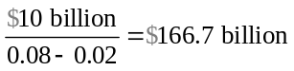
Because the value of the assets equals the value of the liabilities at this discount rate, this is also the value of the assets.
The true value of the liabilities is
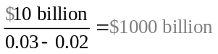.

Thus the plan is underfunded to the tune of $1000 – 166.7 = $833.3 billion.

